SCUBA-2 Block Specification
fsfb_calc

Table of Contents

1. Block Overview 4
1.1 Block Location and Block Interface Within System 4
1.2 Block Functionality / Features 4
1.3 Block Dataflow 4
2. Block Interfaces 6
2.1 Interface Signal Description 6
2.2 Interface Protocol and Timing 8
2.2.1 Constant Mode Timing 8
2.2.2 Ramp Mode Timing 9
2.2.3 Lock Mode Timing 11
3. High-Level Description 12
3.1 First Stage Feedback Queue (fsfb_queue) Bank 0 (Even) and 1 (Odd) 12
3.2 First Stage Feedback Processor (fsfb_processor) 13
3.2.1 Constant Mode 15
3.2.2 Ramp Mode (fsfb_proc_ramp) 15
3.2.3 Lock/PIDZ Mode (fsfb_proc_pidz) 16
3.3 First Stage Feedback Input/Output Controller (fsfb_io_controller) 17
4. Files of the Block 20
4.1 Source Code 20
4.1.1 Fsfb_calc.vhd 20
4.1.1.1 Fsfb_processor.vhd 20
4.1.1.2 Fsfb_io_controller.vhd 20
4.1.1.3 Fsfb_queue.vhd 20
4.2 Header Code 20
4.2.1 Fsfb_calc_pack.vhd 20
5. Naming Conventions Used 21

Table of Figures

Figure 1: First Stage Feedback Calculator 5
Figure 2: Interface Timing Diagram 1 (Constant Servo Mode) 8
Figure 3: Interface Timing Diagram 2-1 (Ramp Servo Mode) 9
Figure 4: Interface Timing Diagram 2-2 (Ramp Servo Mode) 10
Figure 5: Interface Timing Diagram 3 (Lock Servo Mode) 11
Figure 6: First Stage Feedback Queue Data Word 12
Figure 7: First Stage Feedback Queue 13
Figure 8: First Stage Feedback Processor 14
Figure 9: First Stage Feedback Ramp Processor 15
Figure 10: First Stage Feedback Lock/PIDZ Processor 16
Figure 11: First Stage Feedback Input/Output Controller 18

Block Overview

Block Location and Block Interface Within System
The first stage feedback calculator (fsfb_calc) block is instantiated inside each flux loop control block (flux_loop_ctrl) found on the readout card. On each card, there are eight flux_loop_ctrl blocks responsible for the eight different channels.
The first stage feedback calculator (fsfb_calc) stands in the middle of the system datapath. Its upstream input side is interfaced with the adc_sample_coadd block while its downstream output side is interfaced with the first stage feedback control (fsfb_ctrl) and filter (fsfb_fltr) blocks. Note that the filter block is not supported in the initial release of the readout card.

Block Functionality / Features
The fsfb_calc block is responsible for calculating the first stage feedback values, storing them in the first stage feedback queues (fsfb_queue), and providing first stage feedback wishbone (fsfb_ws), control (fsfb_ctrl) and filter (fsfb_fltr) access to these first stage feedback queue storage. It has the following main features:
- Supports three different servo mode calculations: constant/ramp/lock
- Selects the outputs based on the servo mode selection setting
- Provides two banks of first stage feedback queue storage (up to 64 locations of 33 bits, bit 32 is used only in ramp mode) for simultaneous access of previous and current frame results without arbitration
- Gives smooth output transition with the assertion of initialize window input when test setting changes
- Outputs ready signals along with valid data results to downstream blocks for ease of handshaking

Block Dataflow
Figure 1 shows the block dataflow for the first stage feedback calculator (fsfb_calc) block.

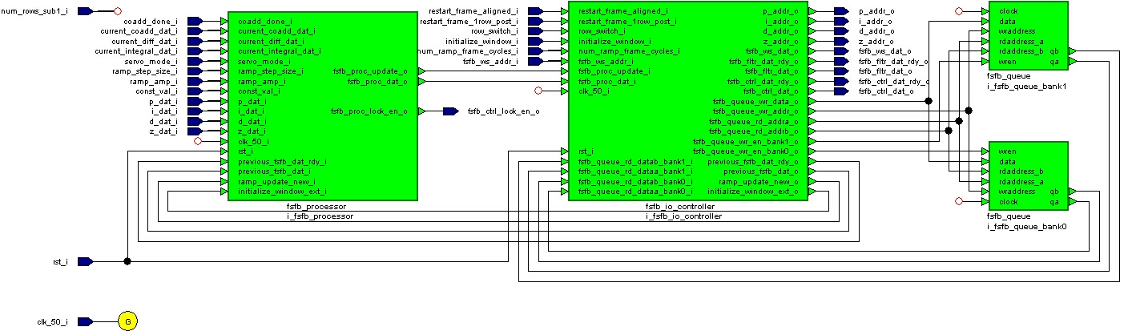
Figure 1: First Stage Feedback Calculator

Block Interfaces

Interface Signal Description
- Interface Signals
Signal | Description | Direction
rst_i | Global block reset | in
clk_50_i | Global clock (50MHz) | in
coadd_done_i | Done signal issued by coadd block to indicate coadd data valid (one clk period pulse) | in
current_coadd_dat_i | Current coadded value (P) | in
current_diff_dat_i | Current difference (D) | in
current_integral_dat_i | Current integral (I) | in
restart_frame_aligned_i | Indicates next clock cycle is the start of frame (one clk period pulse) | in
restart_frame_1row_post_i | Same as restart_frame_aligned_i, except that it is 1 row behind of actual frame start | in
row_switch_i | Row switch signal to indicate next clock cycle is the beginning of new row (one clk period pulse) | in
initialize_window_i | Frame window at which all values read queues equal to fixed preset parameter, FSFB_QUEUE_INIT_VAL, set to 0 | in
num_rows_sub1_i | Number of rows per frame subtract 1 | in
servo_mode_i | Servo mode selection | in
ramp_step_size_i | Ramp step increment/decrement size | in
ramp_amp_i | Ramp peak amplitude | in
const_val_i | First stage feedback constant value | in
num_ramp_frame_cycles_i | Number of frame cycle ramp result remained level | in
p_addr_o | P coefficient queue address | out
p_dat_i | P coefficient queue data | in
i_addr_o | I coefficient queue address | out
i_dat_i | I coefficient queue data | in
d_addr_o | D coefficient queue address | out
d_dat_i | D coefficient queue data | in
z_addr_o | Z coefficient queue address | out
z_dat_i | Z coefficient queue data | in
fsfb_ws_addr_i | First stage feedback queue wishbone address (previous frame) | in
fsfb_ws_dat_o | First stage feedback queue wishbone data (previous frame) | out
fsfb_fltr_dat_rdy_o | First stage feedback queue filter data ready (current frame) | out
fsfb_fltr_dat_o | First stage feedback queue filter data (current frame) | out
fsfb_ctrl_dat_rdy_o | First stage feedback queue control data ready (previous frame) | out
fsfb_ctrl_dat_o | First stage feedback queue control data (previous frame) | out
fsfb_ctrl_lock_en_o | First stage feedback queue control lock data mode enable | out

Interface Protocol and Timing

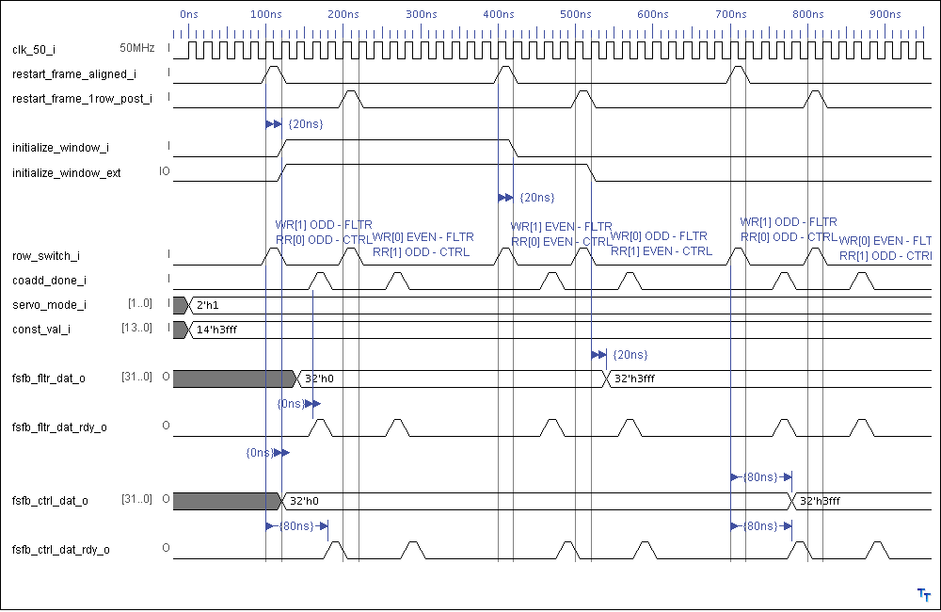
Constant Mode Timing
Figure 2: Interface Timing Diagram 1 (Constant Servo Mode)

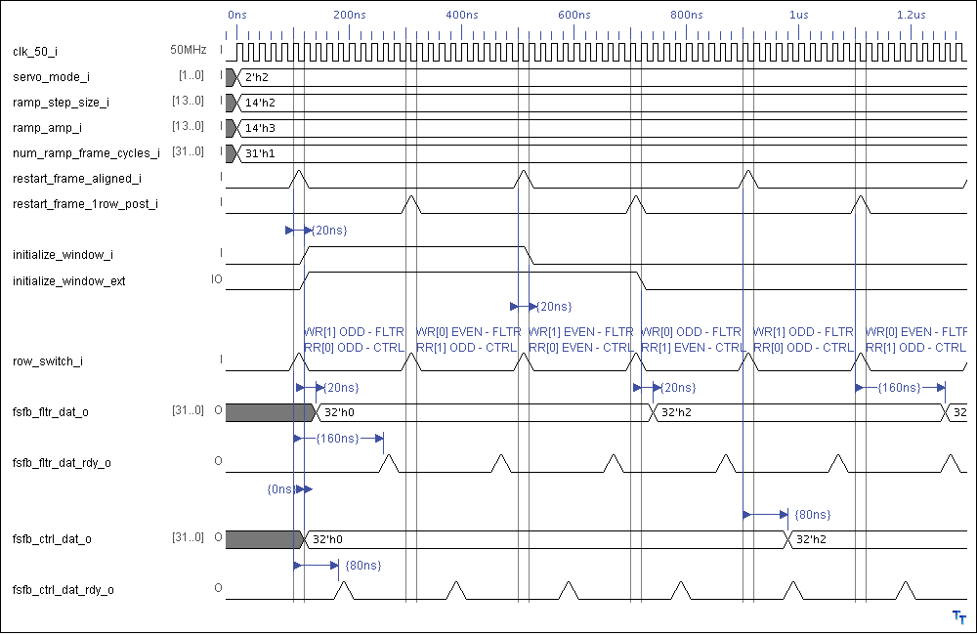
Ramp Mode Timing
Figure 3: Interface Timing Diagram 2-1 (Ramp Servo Mode)
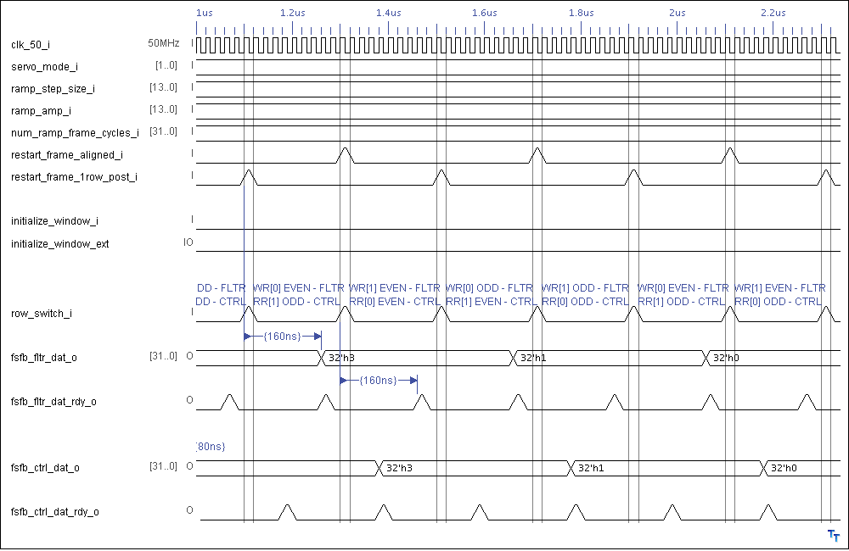
Figure 4: Interface Timing Diagram 2-2 (Ramp Servo Mode)

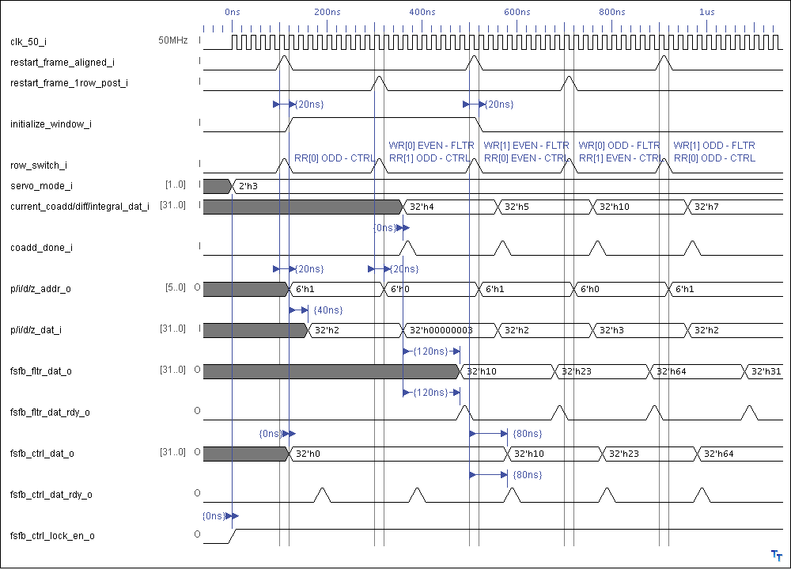
Lock Mode Timing
Figure 5: Interface Timing Diagram 3 (Lock Servo Mode)

High-Level Description
The first stage feedback calculator is architected based on its sub-block functionality. It consists of four main sub-blocks that are the first stage feedback input/output controller (fsfb_io_controller), processor (fsfb_processor) and two banks of queues (fsfb_queue).

First Stage Feedback Queue (fsfb_queue) Bank 0 (Even) and 1 (Odd)
The first stage feedback queues (fsfb_queue) store the calculated results from the first stage feedback processor (fsfb_processor), so that they can later be accessed either by the wishbone (fsfb_ws) or the downstream first stage feedback control (fsfb_ctrl) block. Two queues (odd and even bank) are required, with one storing the previous frame data and the other storing the current frame one. All the queue inputs and outputs are made indirectly via control of the first stage feedback input/output controller (fsfb_io_controller) block. It is important to realize that the fsfb_ws and fsfb_ctrl is always accessing the previous frame data, and not the current one.
The first stage feedback queue is built from Altera 3-port RAM (shown in Figure 7), with one port dedicated to internal system write, another port dedicated to internal system read and the last one dedicated to wishbone read accesses. It has 33-bit data width and 6-bit address width. The address range currently used only spans from 0 to 40 (41 locations) with a potential maximum of up to 64 locations. Bit 32 stores the next ramp operation (add = '0', sub = '1') and bits 31 to 0 store the result. Therefore bit 32 is ignored in all modes expect ramp.

Servo Mode | Bit 32 | Bit 31: 0
01 - Constant | X – don’t care (ignored) | Constant result
10 - Ramp | 0 – add, 1 - subtract | Ramp result
11 - Lock | X – don’t care (ignored) | Lock result
Figure 6: First Stage Feedback Queue Data Word
qa[32:0]

qb[32:0]

data[32:0]

wren
rdaddress_a[5:0]

wraddress[5:0]

rdaddress_b[5:0]

FSFB
QUEUE

33 bits
X
64 words
clk
system
system
wishbone
system
wishbone
Figure 7: First Stage Feedback Queue

First Stage Feedback Processor (fsfb_processor)
The first stage feedback processor (fsfb_processor) shown in Figure 8 contains the arithmetic/comparison circuitry that calculates the results of first stage feedback to be written to the first stage feedback queues (fsfb_queue). It supports three servo processing modes: constant, ramp, and lock corresponding to servo mode selection = "01", "10", and "11". "00" selection is invalid. Under this invalid setting, the update pulse (essentially the queue write enable) would not be generated, and hence there would be no update whatsoever. In addition, only the selected result will be output from this block. In other words, there is only a single output to be used by another block and it is the result for the selected servo mode. For the ramp mode, the new ramp value output by the processor block is only changed when the "ramp update new" input is active.

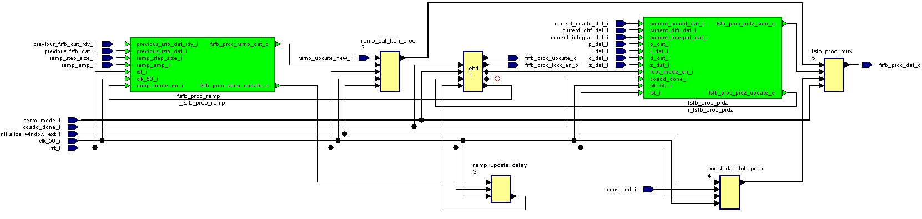

Figure 8: First Stage Feedback Processor

Constant Mode
Constant mode is handled directly by the top-level fsfb_processor block. The constant and servo mode selection values are made available by the wishbone slave feedback data block. These values should be stable before the frame timing block outputs the "initialize window" pulse. The constant value is provided to the downstream first stage feedback filter (fsfb_fltr) and control (fsfb_ctrl) blocks in the second and third frame time window respectively. Note that the update pulse in this mode is derived from the upstream coadd done signal. As long as the coadd done signal is active every row, this is acceptable regardless of mode selection. If not, a delayed version of row switch can be generated to replace coadd done. Figure 2 shows the timing diagram for this mode.

Ramp Mode (fsfb_proc_ramp)
The ramp processor (fsfb_proc_ramp) block shown in Figure 9 handles the ramp mode processing. The ramp step size, amplitude, and servo mode selection are made available by the wishbone slave feedback data block. The values should be stable before the "initialize window" pulse is output by the frame timing block. The generated ramp output always initializes at zero level and gradually increases in step size increments until reaching the maximum level set by the ramp amplitude input. Once it reaches the maximum amplitude, the output ramp is then decremented in the same step size until the zeroed level. The pattern will be repeated continuously. The pace of increment/decrement is dictated by the "ramp_update_new" input controlled by the "num_ramp_frame_cycles" wishbone input. The first ramp increment value is present on the datapath to the downstream first stage feedback filter (fsfb_fltr) and control (fsfb_ctrl) blocks in the num_ramp_frame_cycles + 1 and +2 frame time window respectively. Figure 3 and Figure 4 show the timing diagram for this mode when the num_ramp_frame_cycles is 1. Note that the instantiated 16-bit adder/subtractor is generated through Altera megafunction. The 16-bit add/sub result is zero-padded to 32 bits. Bit 32 is written with '1' when the next ramp operation is subtraction or '0' when addition. This toggling of next operation bit normally occurs when the maximum or zero is reached after a series of ramp addition or subtraction.
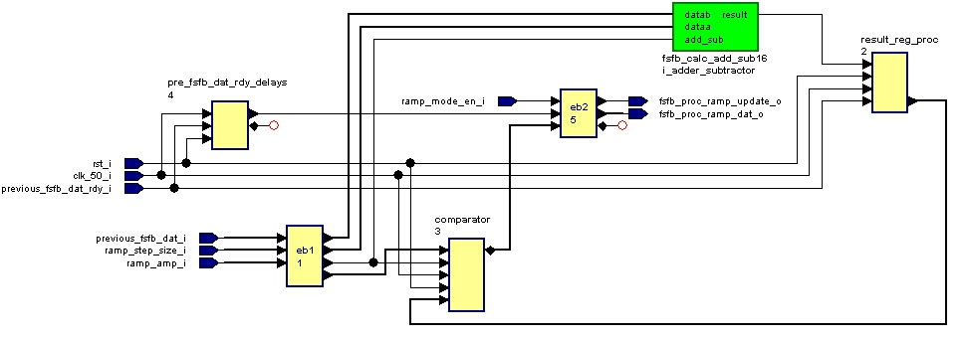
Figure 9: First Stage Feedback Ramp Processor

Lock/PIDZ Mode (fsfb_proc_pidz)
The lock/pidz mode processor (fsfb_proc_pidz) block shown in Figure 10 handles the lock mode processing. The P, I, D, and Z coefficients are made available by the wishbone slave feedback data block. There are 41 different sets of coefficient values stored in the pidz_coeff_queue and they should be stable before the frame timing block outputs the "initialize window" pulse. To implement the lock mode calculation of (P*Current Coadd Value) + (I*Current Integral) + (D*Current Difference) + Z, three 32-bit multipliers, two 64-bit first stage adders, and one 65-bit second stage adder are instantiated. All inputs from the upstream adc_sample_coadd block including Current Coadd Value, Integral and Difference are valid when the coadd done pulse is active. After the active coadd done pulse, it takes a total of 5 clock cycles to complete the lock mode calculation. The multiplier results (P*Current Coadd Value, I*Current Integral, and D*Current Difference) are valid at the end of the third clock cycle, the first stage adder results (P*Current Coadd Value + I*Current Integral, and D*Current Difference + Z) are valid at the fourth and finally the second stage adder result ([P*Current Coadd Value + I*Current Integral] + [D*Current Difference + Z]) is valid at the fifth clock cycle. This relationship is shown in Figure 5where the filter data ready pulse becomes active three clock cycles after the incoming coadd done pulse. As the multiplier is shared, the multiplication process takes three clock cycles to complete. This is done to save the DSP resources. However, there are separate adders for each addition operation. If resource becomes scarce, the shared adder scheme can be adopted. But this of course will increase the latency just like the multiplication above.
It should be noted that although the resultant PIDZ sum is 66-bit wide, the signed result that can be stored is only 32-bit. Because of this, only bits 30 down to 0 represent the magnitude and bit 31 is reserved for sign. This is a limitation of the width size of the first stage feedback queue.
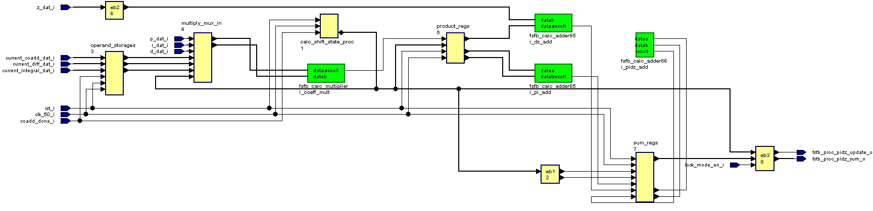

Figure 10: First Stage Feedback Lock/PIDZ Processor

First Stage Feedback Input/Output Controller (fsfb_io_controller)
The first stage feedback input/output controller (fsfb_io_controller) block shown in Figure 11 maintains control over all the input/output to/from the first stage feedback queues. Using signals "row switch, restart frame aligned and restart frame 1row post" output by the frame timing block, the controller block ensures the queue read/write address inputs and even/odd bank switching are updated correctly at the right times. By doing this, correct data would then be read/written from/to the queues. There are three different kinds of queue operation possible and they are 1) wishbone read, 2) system read, and 3) system write. The word "system" refers to the fsfb_calc block.
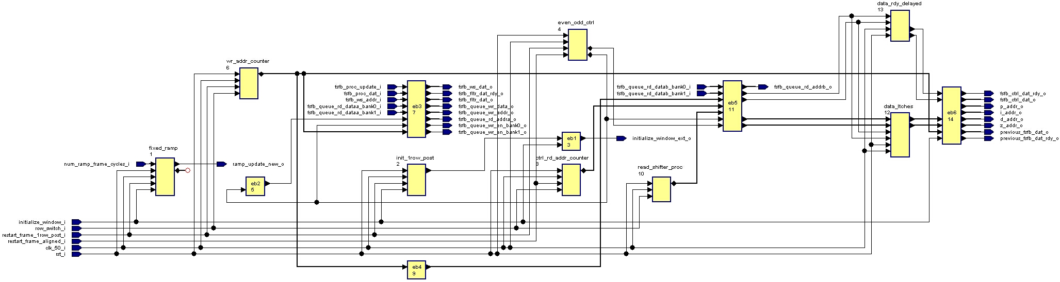
Figure 11: First Stage Feedback Input/Output Controller

As mentioned before in the FSFB_QUEUE section, a separate read port is allocated for the wishbone slave. Ideally, the wishbone slave can request for unfiltered data at anytime. However, to get a complete frame worth of data, the wishbone slave must not perform any read close to the boundary between row 0 and 1 of each frame time. The data read is selected from either bank 0 or 1, dependent on the bank selection control.

For every row switch, the fsfb_io_controller block will perform two sequential reads and the reads are performed regardless of the selected servo mode. From the first read, the first stage feedback queue result data is obtained for the downstream first stage feedback control block. This row result has already been calculated in the previous frame time. From the second read, the first stage feedback queue result data in the previous frame time is fetched to update the current ramp value for use in the next frame time. Similar to the wishbone slave, a separate read port is allocated for the system.

The system write operation is also straightforward. The write data and write enable are always sourced from the fsfb_processor block outputs. The fsfb_io_controller only updates the write address and demultiplexes the write enable to the right bank. It is important to realize that the two-bank queue structure details are not visible to any block except the fsfb_io_controller.

Files of the Block

Source Code

Fsfb_calc.vhd
This is the top-level component for the first stage feedback calculator.

Fsfb_processor.vhd
This is the top-level component for the first stage feedback processor and is part of fsfb_calc.

Fsfb_proc_ramp.vhd
This is the top-level component for the first stage feedback ramp processor and is part of fsfb_processor.

Fsfb_calc_add_sub16.vhd
This is the top-level component for the 16-bit adder/subtractor and is part of fsfb_proc_ramp.

Fsfb_proc_pidz.vhd
This is the top-level component for the first stage feedback lock/pidz processor and is part of fsfb_processor.

Fsfb_calc_adder65.vhd
This is the top-level component for the 65-bit adder and is part of fsfb_proc_pidz.

Fsfb_calc_adder66.vhd
This is the top-level component for the 66-bit adder and is part of fsfb_proc_pidz.

Fsfb_calc_multiplier.vhd
This is the top-level component for the 32-bit multiplier and is part of fsfb_proc_pidz.

Fsfb_io_controller.vhd
This is the top-level component for the first stage feedback input-output controller and is part of fsfb_calc.

Fsfb_queue.vhd
This is the top-level component for the first stage feedback queue and is part of fsfb_calc.

Header Code

Fsfb_calc_pack.vhd
This is the package file for the first stage feedback calculator. It contains all the constant and component declarations used.

Naming Conventions Used

